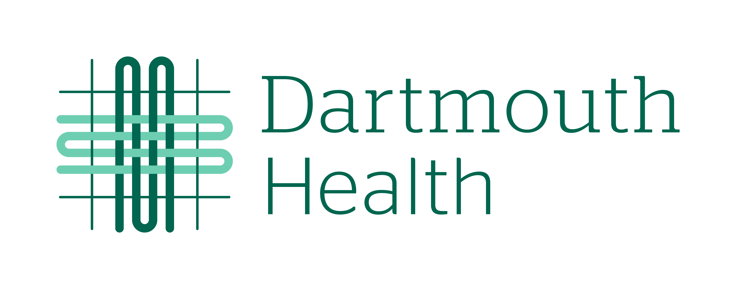  Waiver and Release for Participation in  The North East Consortium of Wilderness  and Austere Medicine | Participant Name: ________________________________  DOB: _________________ Phone: __________________  Email: ___________________________________________  Emergency Contact: _______________________________  (Phone): __________________________

I, _________________________________________, acknowledge and agree that I wish to voluntarily participate in the North East Consortium of Wilderness and Austere Medicine Course (the “NECWAM Course”) being offered through the Departments of Emergency Medicine, Continuing Nurse Education, and Center for Learning and Professional Development at Dartmouth-Hitchcock Clinic and Mary Hitchcock Memorial Hospital, operating jointly and referred to herein as “Dartmouth–Hitchcock.” I understand that my participation in the NECWAM Course is completely voluntary and that the NECWAM Course fee is $25 - $95 (depending on my professional designation) for one day of participation (Saturday, October 8, 2022, from 7:30 am – 5:00 pm). I will receive nursing continuing education credits, physician AMA PRA Category 1 Credit(s), or a certificate of participation depending on my professional designation for this NECWAM Course in the amount of 7.0 if I attend all of the learning activity’s sessions. Part of the NECWAM Course may involve participation in mock rescue exercises. I will be going to The AMC Highland Center at Crawford Notch, Route 302, Bretton Woods, NH, with my instructors and fellow students for this training and education.

The AMC Highland Center at Crawford Notch has an extensive trail network in the white mountains of New Hampshire. The AMC Highland Center at Crawford Notch is a “use at your own risk” area and is not on Dartmouth-Hitchcock property. For more information regarding this property, its use, rules and restrictions, you can visit The AMC Highland Center at Crawford Notch: Highland Center | Appalachian Mountain Club (outdoors.org).

I understand that travel to and from The AMC Highland Center at Crawford Notch and parking of my personal vehicle or other modes of transportation to and from The AMC Highland Center at Crawford Notch as well as those activities and exercises I participate in while at The AMC Highland Center at Crawford Notch could carry the risk of potentially serious injuries or illness, loss or damage to personal property, or financial loss or theft as a result of my participation in the event. I hereby agree to voluntarily assume the full risk of any and all injury, damage, and loss of any kind arising out of my participation in the NECWAM Course and these voluntary activities. I am solely responsible for my own personal belongings while attending the NECWAM Course.

I understand that if I choose to book the discounted lodging at $100 per night associated with the NECWAM Course registration for the evening of Friday, October 7, 2022, and/or Saturday, October 8, 2022, at The AMC Highland Center at Crawford Notch, I’m reserving a single bunk in a shared space, and will have access to a shared bathroom. The cost of lodging includes breakfast and dinner at The AMC Highland Center at Crawford Notch. I hereby agree to voluntarily assume the full risk of any and all injury, damage, illness, and loss of any kind arising out of my decision to stay overnight at The AMC Highland Center at Crawford Notch. I am solely responsible for my own personal belongings while attending these classes.

In signing this waiver, I, on behalf of myself, my heirs, executors, administrators and personal representatives, release and forever discharge Dartmouth-Hitchcock its affiliates, subsidiaries, and related entities and any and all of their directors, officers, employees, agents assigns, successors, representatives, and insurers from any and all risks or injuries, damages, harm, or financial losses that occur to me as a result of my voluntary participation in the NECWAM Course and voluntary activities at The AMC Highland Center at Crawford Notch, Bretton Woods, NH whether or not the liability, loss or damage is caused in whole or in part by the failure by Dartmouth-Hitchcock, their affiliates, subsidiaries, or related entities, or each of its or their directors, officers, agents, employees, assigns, successors, or representatives to use reasonable care.

By signing below, I acknowledge and agree that I am 18 years of age or older, have read and understand the terms of this Waiver and Release for Participation in The North East Consortium of Wilderness and Austere Medicine, and agree to its terms.

________________________________ _________________________________ _________________

Name of Participant Signature of Participant Date Signed

