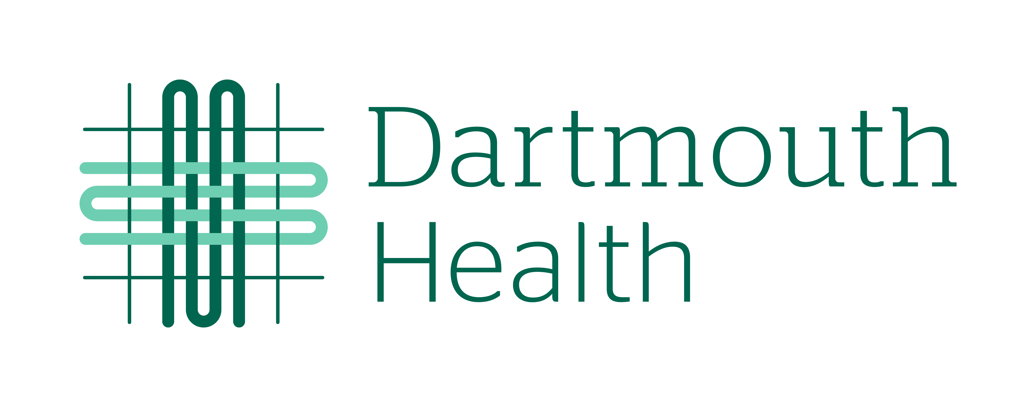  Waiver and Release  Wilderness First Aid Course  for  Nurses and EMTs | Participant Name: ________________________________  DOB: _________________  Phone: __________________  Email: ________________________________________  Emergency Contact: ______________________________  (Phone): __________________________

I, _________________________________________, acknowledge and agree that I wish to voluntarily participate in the Wilderness First Aid Course for Nurses being offered through the Departments of Emergency Medicine and Continuing Nurse Education at Dartmouth Hitchcock. I understand that my participation is completely voluntary and that the course fee is $75.00 - $175.00 for two days of participation on September 29th, from 7:45 am – 4:30 pm, and September 30th, from 8:00 am – 4:15 pm). I will receive up to 14.5 nursing continuing education credits or a certificate of attendance for participation in this course. Part of the course will involve participation in mock rescue exercises. I will be going to Boston Lot, Lebanon, NH, with my instructors and fellow students for this portion of the training and education.

Boston Lot is a forested area with hiking trails and a reservoir at the peak (683 feet). Boston Lot is a “use at your own risk” area and is not on Dartmouth Hitchcock property. For more information regarding this property, its use, rules, and restrictions, you can visit Boston lot: Lebanon, NH

I understand that traveling to and from Boston Lot and parking my personal vehicle or other modes of transportation to and from Boston Lot as well as those activities and exercises I participate in while at Boston Lot, could carry the risk of potentially serious injuries or illness, loss or damage to personal property, or financial loss or theft as a result of my participation in the event. I agree to voluntarily assume the full risk of any and all injury, damage, and loss arising from my participation in these voluntary activities. I am responsible for my own personal belongings while attending these classes.

In signing this waiver, I release and forever discharge Dartmouth Hitchcock, the Dartmouth Hitchcock Clinic, Mary Hitchcock Memorial Hospital, and any and all of their directors, officers, employees, and insurers from any and all risks or injuries, damages, harm, or financial losses that occur to me as a result of my voluntary participation in the Wilderness First Aid Course for Nurses activities at Boston Lot, Lebanon, NH.

________________________________ _________________________________ _________________

Name of Participant Signature of Participant Date Signed

